Data Sources Documentation
Alec De Sousa (500918882)
alec.desousa@torontomu.ca
Hermes Hui (500763595)
hchui@torontomu.ca
April 3rd, 2026

Kaggle Canada Housing Dataset
The dataset leveraged for this project was found on kaggle.com [1]. This data was scraped from the Remax Canada website, and was uploaded on February 16th 2025 by Yuliia Bulana. This dataset contains property information extracted from listings on the Remax Canada website, including features such as address details (street address, locality, region, and postal code), geolocation (latitude and longitude), property attributes (beds, baths and square footage), and more.
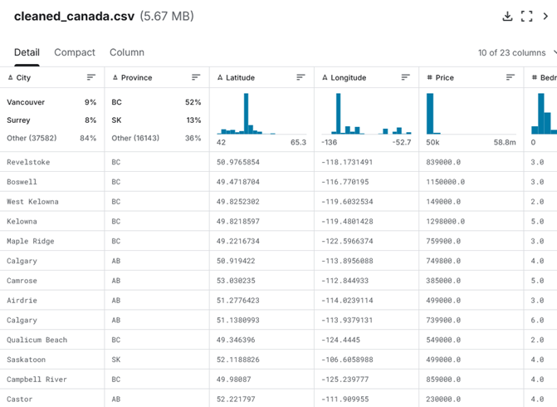
The data, as seen on the Kaggle website [1]
This dataset consists of data on 9 provinces and 3 territories (Quebec is excluded). The scope of this project is only concerned with properties in Ontario, and so data_on.csv (the dataset limited to Ontario) was used. Likewise, this dataset has 396 attributes which is both superfluous for this project, and also unnecessary in the sense that many of these attributes contain missing values or otherwise meaningless data. Due to this, the number of attributes was limited to 29. After our adjustments, the final dataset consists of 29194 listings (instances) in the province of Ontario, with 29 attributes (streetAddress, addressLocality, postalCode, price, property-beds, property-baths, property-sqft, Basement, Bath, Exterior, Exterior Features, Features, Fireplace, Garage, Heating, MLS® #, Partial Bathroom, Property Tax, Property Type, Roof, Sewer, Square Footage, Subdivision, Type, Parking, Flooring, Parking Features, Fireplace Features, and MLS).
References
[1] Yuliia Bulana, “Canada Housing,” Kaggle.com, 2025. https://www.kaggle.com/datasets/yuliiabulana/canada-housing?select=data_on.csv.

